DEERWALK INSTITUTE OF TECHNOLOGY
Tribhuvan University
Faculties of Computer Science

Bachelor of Science in Computer Science and Information
Technology
(BSc. CSIT)
Course: Numerical Method (CSC-207)
Class of 2027/Semester: III
A Lab Report On:
Solution of non-linear equations
Submitted to:
Er Ganesh Thapa
Faculty, Department of Computer Science
Submitted by:
Name: Shaurav Bhandari
Roll No: 1333

LAB 1
TITLE: Solution of Non-linear Equations

OBJECTIVES:
To find the root of non-linear equations using various iterative methods.
THEORY:
Non-Linear equations are equations that do not form a straight line when graphed. These equations involve variables with degrees more than 1, such as quadratic equations, cubic equations, etc.
Bisection method
The bisection method is a simple and robust numerical method to find the root of a continuous function within a given interval by repeatedly dividing the interval in half and selecting a sub-interval in which the root exists. The following are some of the methods to find the root of a non linear equation.
Newton-Raphson method
The Newton-Raphson method involves using an iterative approach to find successively better approximations to the roots of a real-valued function.
Secant method
This method finds the root of a function by constructing a sequence of roots of secant lines that converge to a root of a function.
Fixed-point iteration method
The fixed-point iteration method transforms the problem of finding the root of a function into finding a fixed-point of a finction , where, .
PRACTICAL IMPLEMENTATION

TASK 1: BISECTION METHOD
Solving the non- linear equation cosx - xe^{x} = 0 correct to 3 decimal places using bisection method.

ALGORITHM:
- Start
- Define a function
- Take two initial guesses: and error criteria, e
- Compute
- If print “wrong display” and repeat from step 2 until .
- Compute
- If
- If , the root is .
- Print x as root.

SOURCE CODE:

OUTPUT:
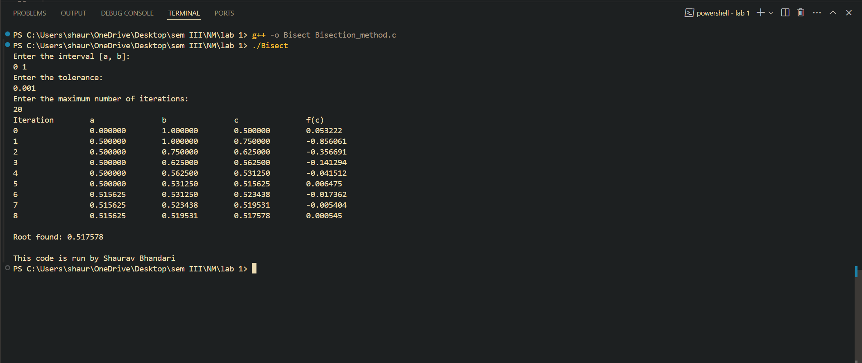

TASK 2: NEWTON RAPHSON METHOD
Solving the non- linear equation 3*x - cos(x) -1 correct to 3 decimal places using Newton-Raphson method.

ALGORITHM:
- Start
- Define a function
- Input the initial guess .
- Compute .
- Compute
- If , print root = x. Else, and repeat from step 4 until true.
- Stop.

SOURCE CODE:

OUTPUT:
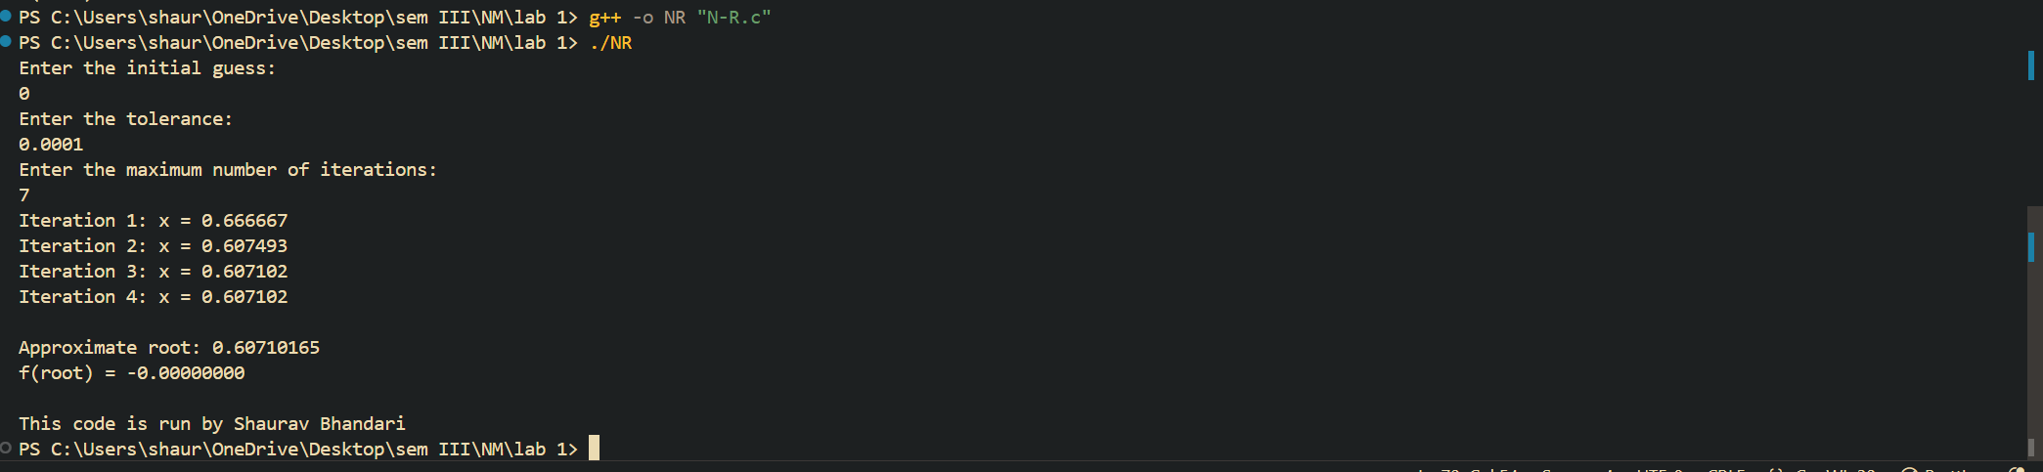

TASK 3: SECANT METHOD
Solving the non- linear equation x³ - 2x – 5 correct to 3 decimal places using secant method.

ALGORITHM:
- Start
- Define a function
- Input the initial guess .
- Compute .
- Compute
- If , print . Else, and repeat from step 4 until true.
- Stop.

SOURCE CODE:

OUTPUT:
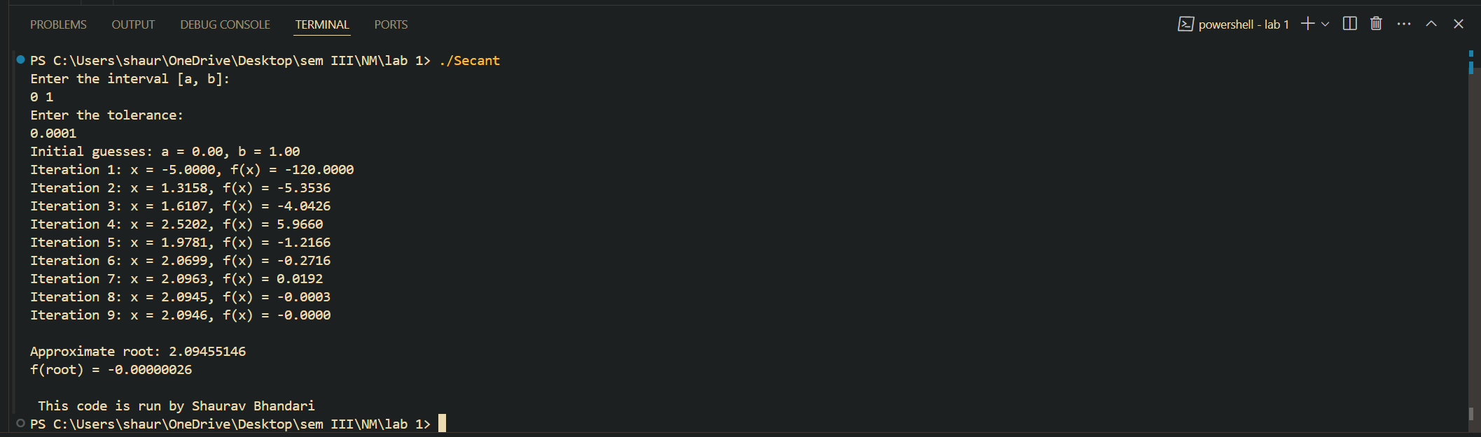

TASK 4: FIXED POINT ITERATION METHOD
Solving the non- linear equation cos(x)-3x+1 correct to 3 decimal places using fixed point iteration method.

ALGORITHM:
- Start
- Define a function
- Input the initial guess .
- Compute .
- If , print . Else, and repeat from step 4 until true.
- Stop.

SOURCE CODE:

OUTPUT:
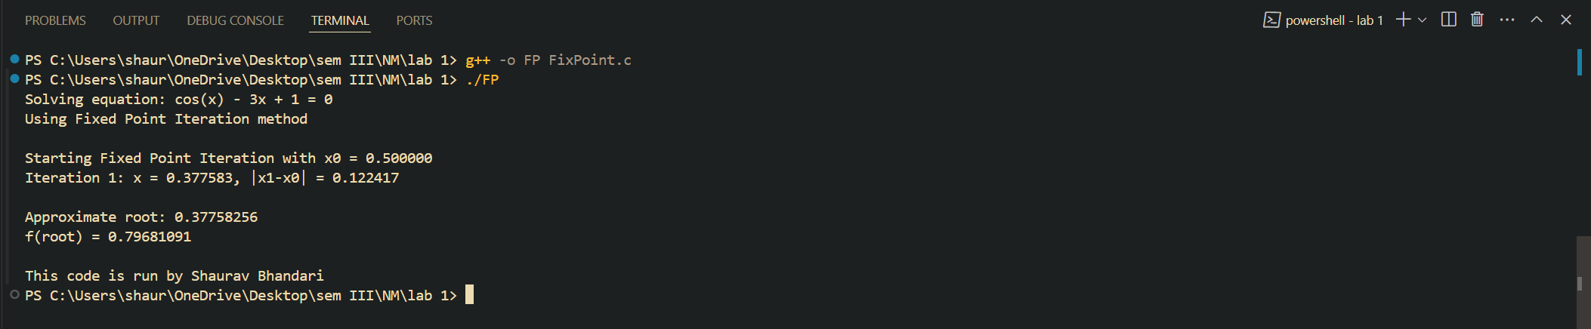

CONCLUSION:
The implementation of various numerical methods for finding approximate roots of non-linear equations were successfully carried out using the C-Programming Language. Libraries such as math.h were utilized to handle mathematical computations effectively. The results demonstrate the efficiency and practicality of these methods in solving complex equations by providing approximate solutions with high degree of accuracy. Hence, it was concluded that these methods were effective in accurate and precise calculation of roots of non-linear equations.

